**Military Institute of Science of Technology**

**Mirpur Cantonment, Dhaka**



**Department of Computer Science & Engineering**

**COURSE CODE : CSE -302**

**REPORT ON**  **Police Station Criminal Record Management System.**

**SUBMITTED BY**

**GROUP-012**

**Tanjim Sakib (201914008)**

**Md. Ahsan Rahat (201914037)**

**Introduction:**

In our Online Police Station Crime Record Management System we use PHP and Oracle Database. This project keeps the records of FIR, Criminals, and details of victims. Crime Record Management System has the following modules,

* Admin
* Viewer

**Admin Module :**

1. Add
2. Remove
3. Update
4. Update History
5. Viewer’s Information
6. Report

These operations can be done by admin. He can add/remove/update data & can view the update history & viewer information & can create a criminal report .

**Viewer Module :**

1. Search
2. Create report
3. Wanted list

Viewers can search a criminal by his/her name & also can create a criminal report & as well as can view the wanted list.

**Present System:**

Currently criminal records are stored manually in pen & paper in Bangladesh & later this data is uploaded in a central database.

No automated system is yet to be developed where there is a module called viewer who can search for criminal details as well as can have the wanted list.In the present system , the central database only contains criminal data , it can't create any kind of criminal report .

As there is no viewer module , the local police station cant access criminal details directly. As a result sometimes it's hard for them to take action for a specific criminal & sometimes the criminals escape .

For that kind of reason this system should be developed .

**Proposed System:**

* **Conceptual Design:**

1. **ER DIAGRAM**

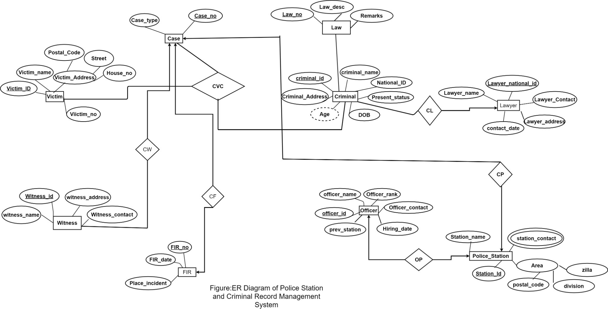

1. **SCHAMA DIAGRAM**

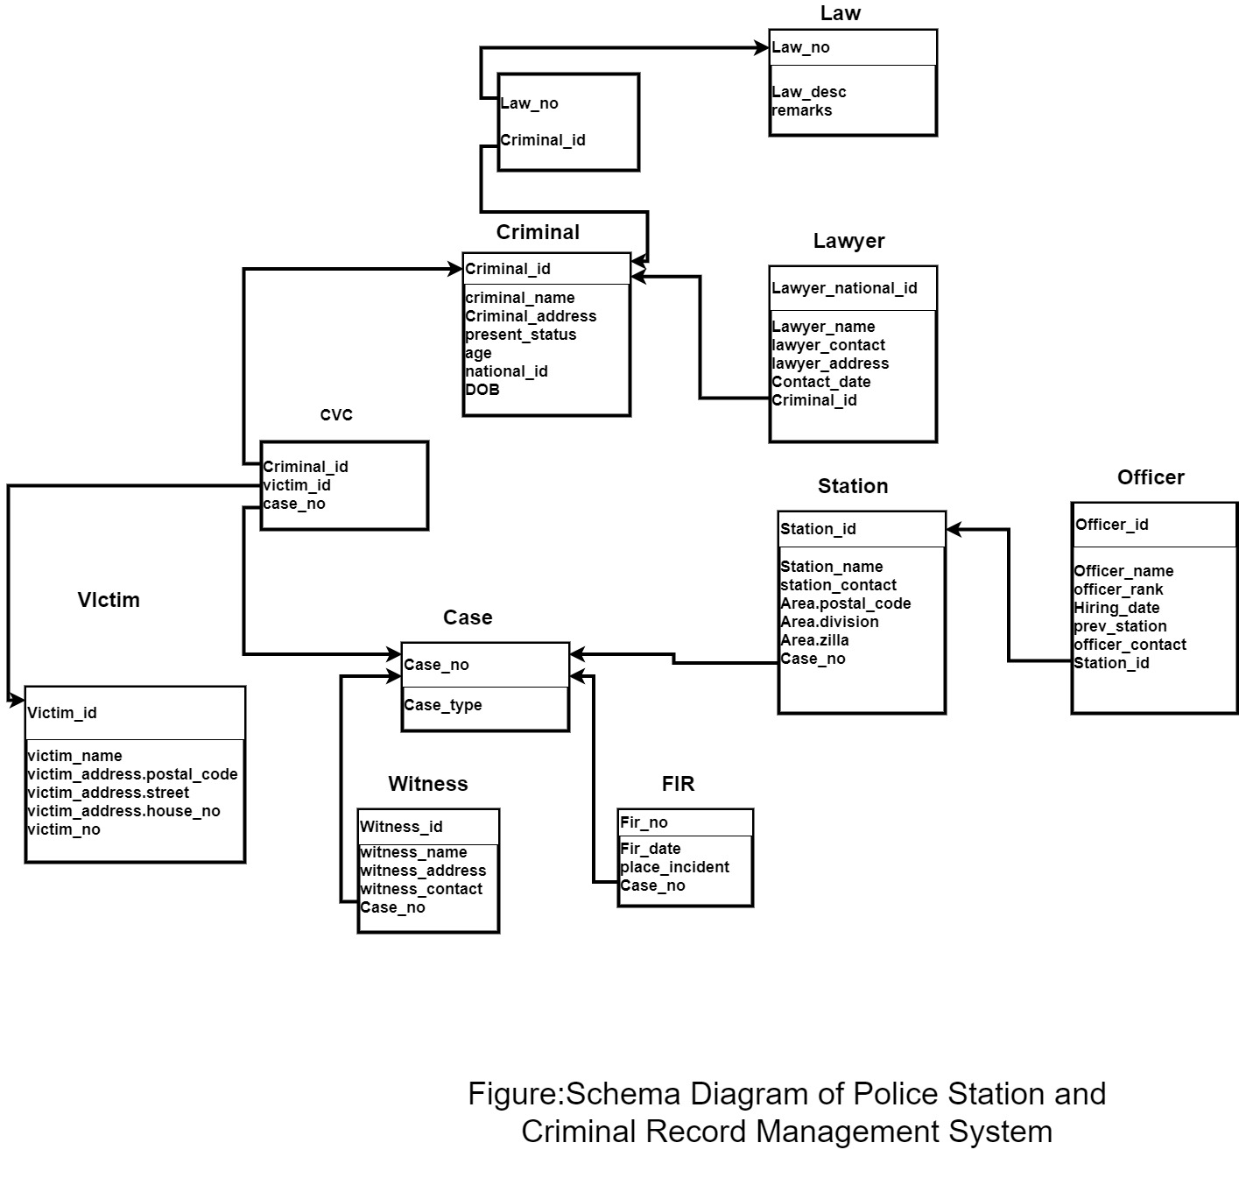

* **Development of the System:**

**Sign up :**

Using this page anyone can create an account (admin / non admin).

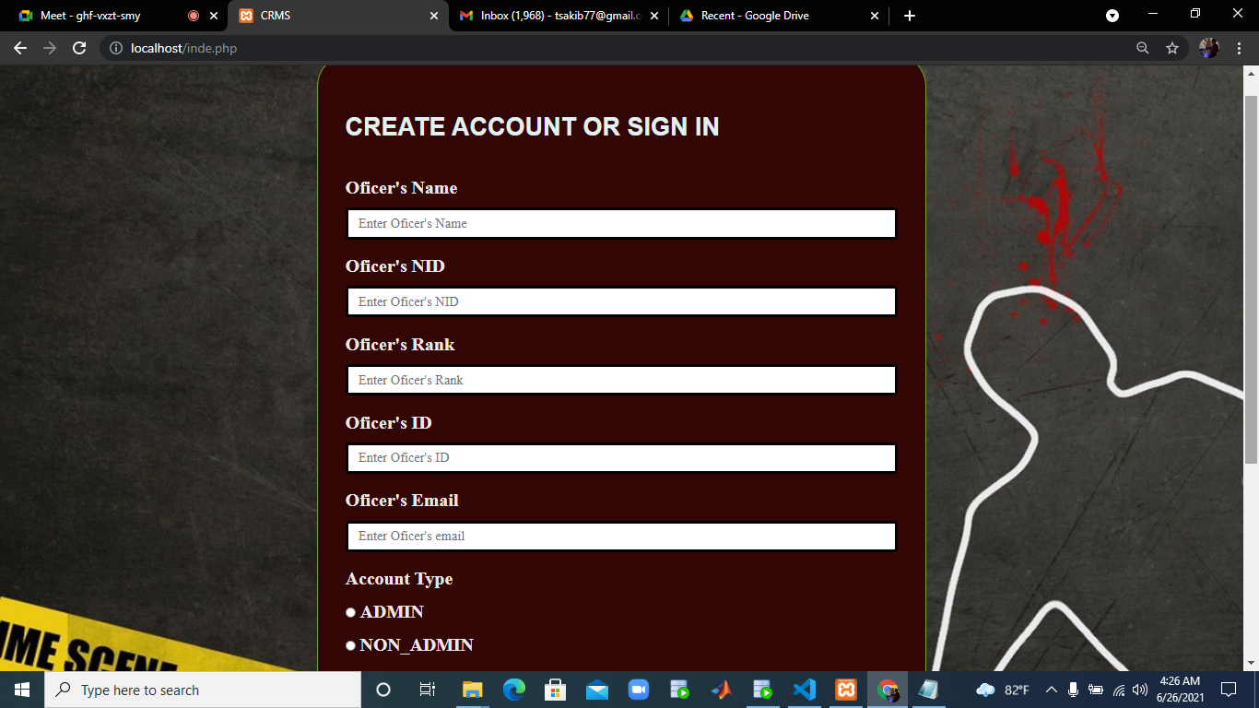

**Sign in :**

Using this page anyone who has an account can log in their account .

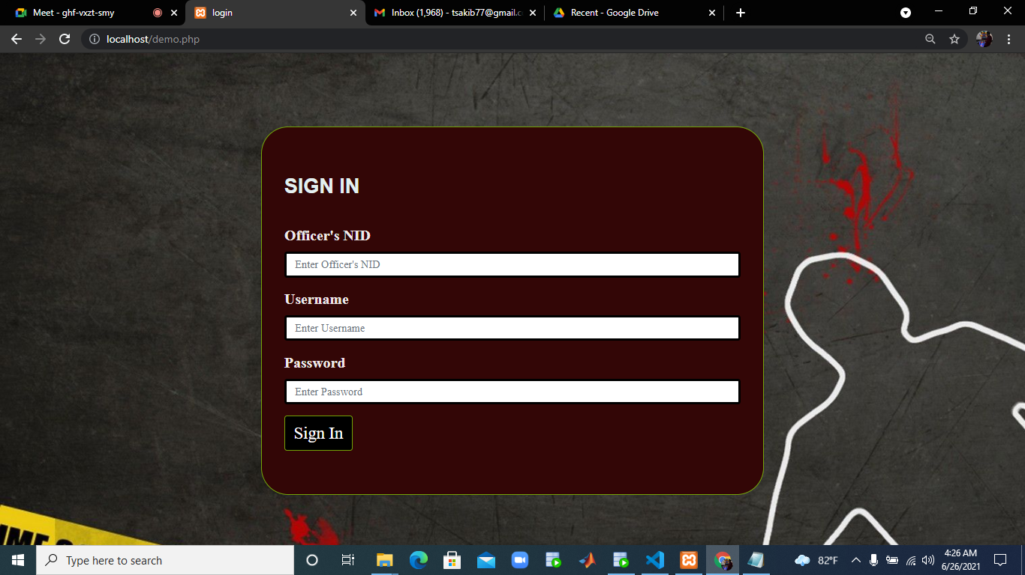

**Admin account :**

According to our features an admin can add, remove , update data in the database . Admin also can view all data & can create reports as well as view visitors information .

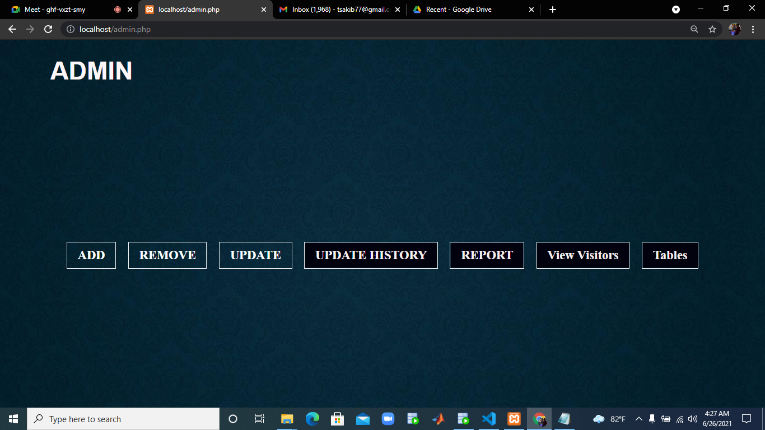

**Add information :**

If an admin chooses the option to add data then he can observe an interface like shown below . He can add data for criminals, witnesses, officers etc.

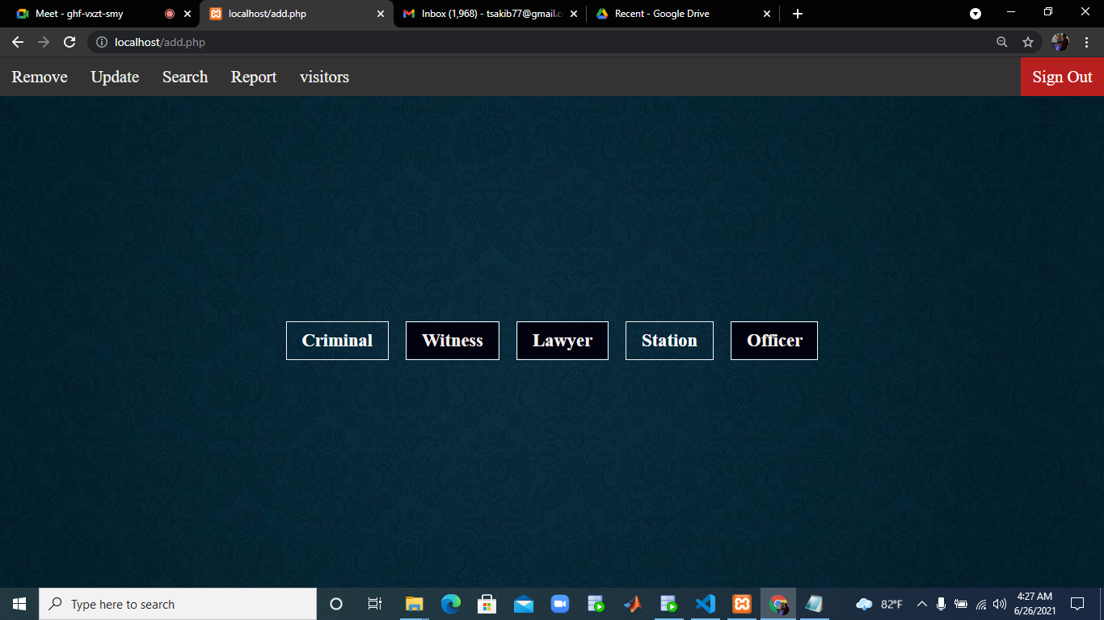

**Add criminal information :**

If an admin wants to add criminal information , he will be shown an interface like shown below .

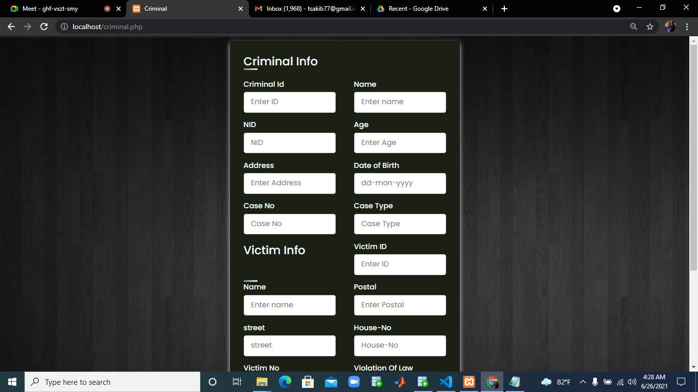

**Remove data:**

If an admin wants to remove a criminal info then he will be shown the criminal details to confirm that this is the criminal whose data will be removed .

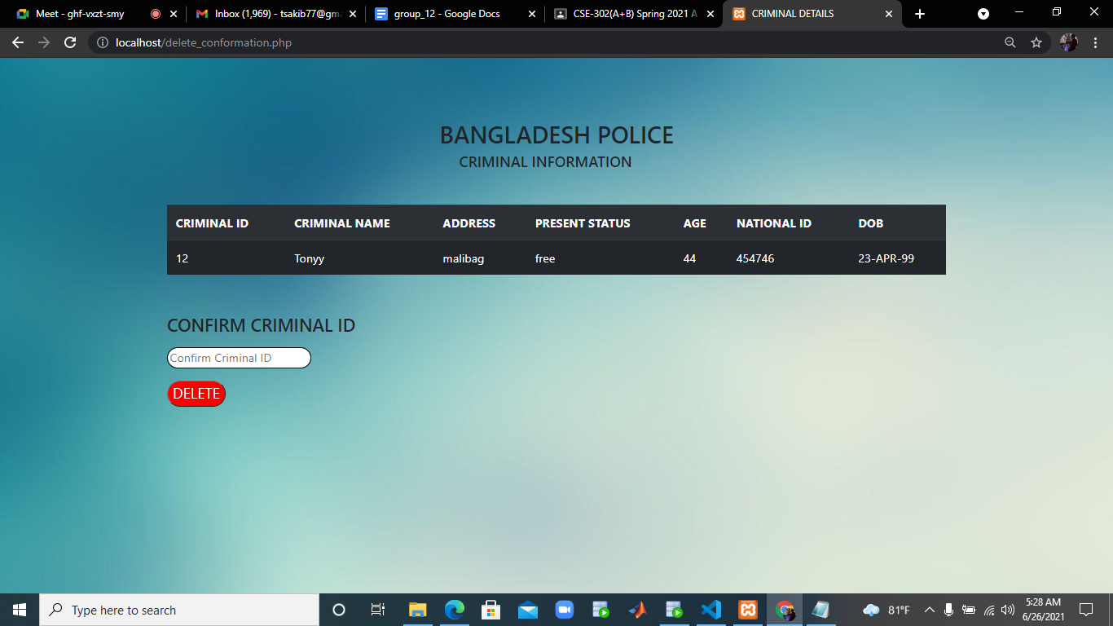

**Update data:**

If an admin chooses to update data he will be shown this interface , by filling up this form he can update data .

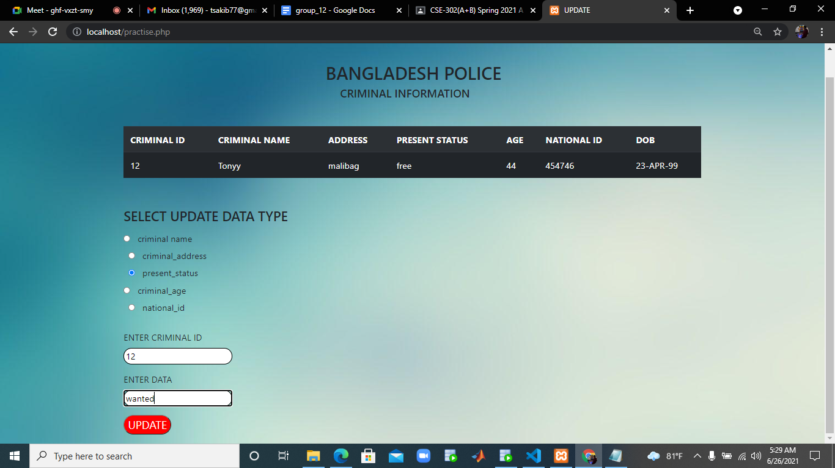

**Report :**

An admin or a viewer can create a report & he or she will able to download it by its pdf form.

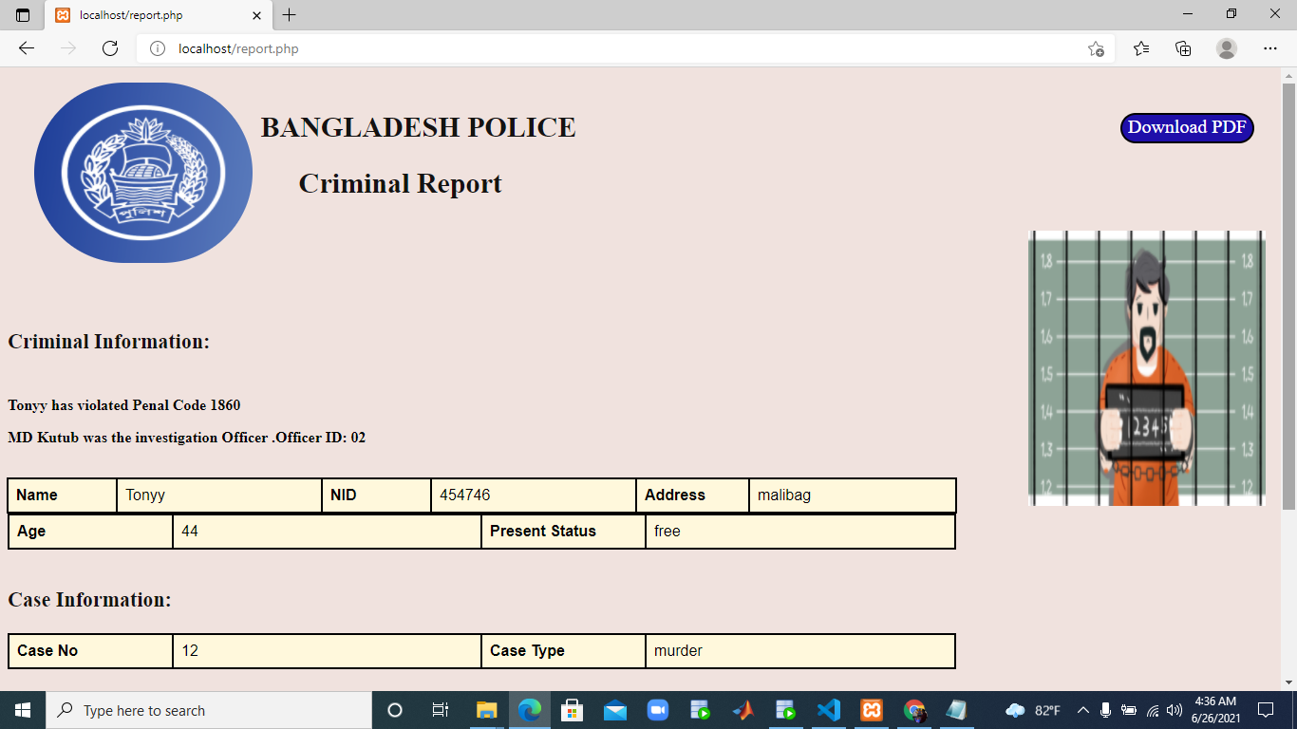

**Viewer :**

The viewer interface will be like shown below . He is able to search or create reports & is able to view the wanted list.

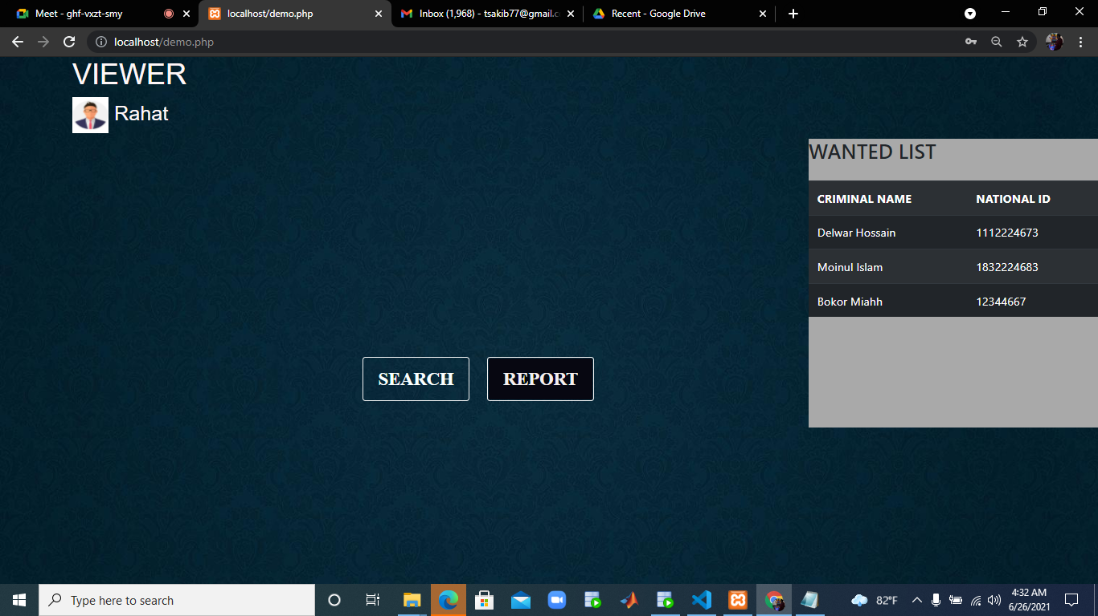

* **System Requirement:**

|  |  |  |  |
| --- | --- | --- | --- |
| **OS Version** | **Front End** | **Back End** | **CODE EDITOR** |
| **Windows 10** | **HTML,CSS,PHP** | **ORACLE 11G** | **VS CODE** |

**\*\*Installation guide is attached to a txt file named installation_guide.txt .**

**Discussion:**

The goal of this project is to gather information of any crime in a systematic way, so that it could be easier to find all the details of a particular crime in a short time without getting into much trouble.Here in the admin sector, an admin will be allowed to enter information of a newly occurred crime using this user friendly interface easily.In present system it is not possible to gather information of a crime in one place like this.The viewers will see a wanted list as soon as they enter which will keep them updated if they are arrested or seen publicly .Finally, they will be able to create a report of any specific criminal which contains the details of the crime in a single place.These features will help the Police Department to manage criminal records in a more faster and effective way.

**Limitation and future expansion:**

One limitation could be that we haven’t added a picture of every individual criminal as it was not possible during this pandemic situation.It can be easily added where there will be an additional column holding the location of each crimanl’s image.

Another limitation is that here we considered this whole project only for the police officers and not for the public.An additional user ‘public’ can be added in the future where they will be able to see limited information of any criminal.

**Conclusion:**

At present the criminal record management system is not that effective in a sense that it doesn’t have the features that will help one to easily get the required information in a short and simple way.Hopefully this project will help The department to collect criminal details more easily compared to the old system.